Name-rahul kakkar
Batch-19
Sap id-590025987

Q1 objective-.Take a random input of thousand number and perform the following algorithm
1.Time comparison of linear and binary search.
2.comparison of bubble sort,insertion sort,quick sort,merge sort.

Code-
#include <stdio.h>
#include <stdlib.h>
#include <time.h>

#define N 1000

// Function for Linear Search
int linearSearch(int a[], int n, int key)
{
for (int i = 0; i < n; i++)
{
if (a[i] == key)
return i;
}

return -1;
}

// Function for Binary Search
int binarySearch(int a[], int n, int key)
{
int low = 0, high = n - 1;

while (low <= high)
{
int mid = (low + high) / 2;

if (a[mid] == key)
return mid;
else if (a[mid] < key)
low = mid + 1;
else
high = mid - 1;
}

return -1;
}

// Bubble Sort
void bubbleSort(int a[], int n)
{
for (int i = 0; i < n - 1; i++)
{
for (int j = 0; j < n - i - 1; j++)
{
if (a[j] > a[j + 1])
{
int temp = a[j];
a[j] = a[j + 1];
a[j + 1] = temp;
}
}
}
}

// Insertion Sort
void insertionSort(int a[], int n)
{
for (int i = 1; i < n; i++)
{
int key = a[i];
int j = i - 1;

while (j >= 0 && a[j] > key)
{
a[j + 1] = a[j];
j--;
}

a[j + 1] = key;
}
}

// Quick Sort
void quickSort(int a[], int low, int high)
{
if (low < high)
{
int pivot = a[high];
int i = low - 1;

for (int j = low; j < high; j++)
{
if (a[j] < pivot)
{
i++;

int temp = a[i];
a[i] = a[j];
a[j] = temp;
}
}

int temp = a[i + 1];
a[i + 1] = a[high];
a[high] = temp;

int p = i + 1;

quickSort(a, low, p - 1);
quickSort(a, p + 1, high);
}
}

// Merge function
void merge(int a[], int low, int mid, int high)
{
int temp[N];
int i = low;
int j = mid + 1;
int k = low;

while (i <= mid && j <= high)
{
if (a[i] < a[j])
{
temp[k] = a[i];
i++;
}
else
{
temp[k] = a[j];
j++;
}

k++;
}

while (i <= mid)
{
temp[k] = a[i];
i++;
k++;
}

while (j <= high)
{
temp[k] = a[j];
j++;
k++;
}

for (i = low; i <= high; i++)
{
a[i] = temp[i];
}
}

// Merge Sort
void mergeSort(int a[], int low, int high)
{
if (low < high)
{
int mid = (low + high) / 2;

mergeSort(a, low, mid);
mergeSort(a, mid + 1, high);

merge(a, low, mid, high);
}
}

int main()
{
int original[N];
int a[N];
int key;

clock_t start, end;
double time_taken;

// Generate 1000 random numbers
srand(time(NULL));

for (int i = 0; i < N; i++)
{
original[i] = rand() % 10000;
}

printf("1000 random numbers generated.\n\n");

// ---------------- SEARCHING ----------------

key = original[500];

// Linear Search
start = clock();

linearSearch(original, N, key);

end = clock();

time_taken = ((double)(end - start)) / CLOCKS_PER_SEC;

printf("Linear Search Time = %f seconds\n", time_taken);

// First sort the array for Binary Search
for (int i = 0; i < N; i++)
{
a[i] = original[i];
}

quickSort(a, 0, N - 1);

// Binary Search
start = clock();

binarySearch(a, N, key);

end = clock();

time_taken = ((double)(end - start)) / CLOCKS_PER_SEC;

printf("Binary Search Time = %f seconds\n\n", time_taken);

// ---------------- SORTING ----------------

// Bubble Sort
for (int i = 0; i < N; i++)
a[i] = original[i];

start = clock();

bubbleSort(a, N);

end = clock();

time_taken = ((double)(end - start)) / CLOCKS_PER_SEC;

printf("Bubble Sort Time = %f seconds\n", time_taken);

// Insertion Sort
for (int i = 0; i < N; i++)
a[i] = original[i];

start = clock();

insertionSort(a, N);

end = clock();

time_taken = ((double)(end - start)) / CLOCKS_PER_SEC;

printf("Insertion Sort Time = %f seconds\n", time_taken);

// Quick Sort
for (int i = 0; i < N; i++)
a[i] = original[i];

start = clock();

quickSort(a, 0, N - 1);

end = clock();

time_taken = ((double)(end - start)) / CLOCKS_PER_SEC;

printf("Quick Sort Time = %f seconds\n", time_taken);

// Merge Sort
for (int i = 0; i < N; i++)
a[i] = original[i];

start = clock();

mergeSort(a, 0, N - 1);

end = clock();

time_taken = ((double)(end - start)) / CLOCKS_PER_SEC;

printf("Merge Sort Time = %f seconds\n", time_taken);

return 0;
}
Code for graph:
import random
import time
import matplotlib.pyplot as plt

# Number of elements
N = 1000

# Generate 1000 random numbers
original = [random.randint(1, 10000) for _ in range(N)]

# ------------------------------------------------
# SEARCHING ALGORITHMS
# ------------------------------------------------

# Linear Search
def linear_search(arr, key):
for i in range(len(arr)):
if arr[i] == key:
return i
return -1

# Binary Search
def binary_search(arr, key):
low = 0
high = len(arr) - 1

while low <= high:
mid = (low + high) // 2

if arr[mid] == key:
return mid
elif arr[mid] < key:
low = mid + 1
else:
high = mid - 1

return -1

# ------------------------------------------------
# SORTING ALGORITHMS
# ------------------------------------------------

# Bubble Sort
def bubble_sort(arr):
n = len(arr)

for i in range(n - 1):
for j in range(n - i - 1):

if arr[j] > arr[j + 1]:
arr[j], arr[j + 1] = arr[j + 1], arr[j]

# Insertion Sort
def insertion_sort(arr):
for i in range(1, len(arr)):

key = arr[i]
j = i - 1

while j >= 0 and arr[j] > key:
arr[j + 1] = arr[j]
j -= 1

arr[j + 1] = key

# Quick Sort
def quick_sort(arr):
if len(arr) <= 1:
return arr

pivot = arr[-1]

left = []
right = []

for x in arr[:-1]:
if x <= pivot:
left.append(x)
else:
right.append(x)

return quick_sort(left) + [pivot] + quick_sort(right)

# Merge Sort
def merge_sort(arr):

if len(arr) <= 1:
return arr

mid = len(arr) // 2

left = merge_sort(arr[:mid])
right = merge_sort(arr[mid:])

result = []

i = 0
j = 0

while i < len(left) and j < len(right):

if left[i] < right[j]:
result.append(left[i])
i += 1
else:
result.append(right[j])
j += 1

result.extend(left[i:])
result.extend(right[j:])

return result

# ------------------------------------------------
# SEARCH TIME COMPARISON
# ------------------------------------------------

key = original[500]

# Linear Search
start = time.perf_counter()
linear_search(original, key)
linear_time = time.perf_counter() - start

# Binary Search needs sorted array
sorted_array = sorted(original)

start = time.perf_counter()
binary_search(sorted_array, key)
binary_time = time.perf_counter() - start

print("SEARCHING")
print("-----------------------")
print("Linear Search :", linear_time)
print("Binary Search :", binary_time)

# ------------------------------------------------
# SORTING TIME COMPARISON
# ------------------------------------------------

# Bubble Sort
arr = original.copy()

start = time.perf_counter()
bubble_sort(arr)
bubble_time = time.perf_counter() - start

# Insertion Sort
arr = original.copy()

start = time.perf_counter()
insertion_sort(arr)
insertion_time = time.perf_counter() - start

# Quick Sort
arr = original.copy()

start = time.perf_counter()
quick_sort(arr)
quick_time = time.perf_counter() - start

# Merge Sort
arr = original.copy()

start = time.perf_counter()
merge_sort(arr)
merge_time = time.perf_counter() - start

print("\nSORTING")
print("-----------------------")
print("Bubble Sort :", bubble_time)
print("Insertion Sort :", insertion_time)
print("Quick Sort :", quick_time)
print("Merge Sort :", merge_time)

# ------------------------------------------------
# GRAPH 1 - SEARCHING
# ------------------------------------------------

search_names = ["Linear Search", "Binary Search"]
search_times = [linear_time, binary_time]

plt.figure(figsize=(8, 5))

plt.bar(search_names, search_times)

plt.xlabel("Searching Algorithm")
plt.ylabel("Time (seconds)")
plt.title("Linear Search vs Binary Search")

plt.show()

# ------------------------------------------------
# GRAPH 2 - SORTING
# ------------------------------------------------

sort_names = [
"Bubble Sort",
"Insertion Sort",
"Quick Sort",
"Merge Sort"
]

sort_times = [
bubble_time,
insertion_time,
quick_time,
merge_time
]

plt.figure(figsize=(9, 5))

plt.bar(sort_names, sort_times)

plt.xlabel("Sorting Algorithm")
plt.ylabel("Time (seconds)")
plt.title("Sorting Algorithm Comparison")

plt.show()

Output-
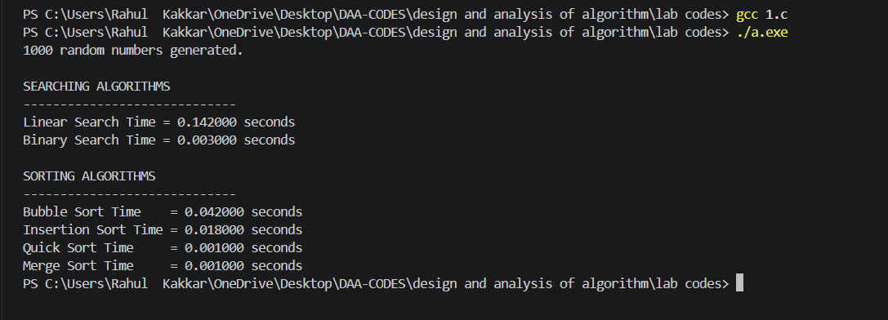
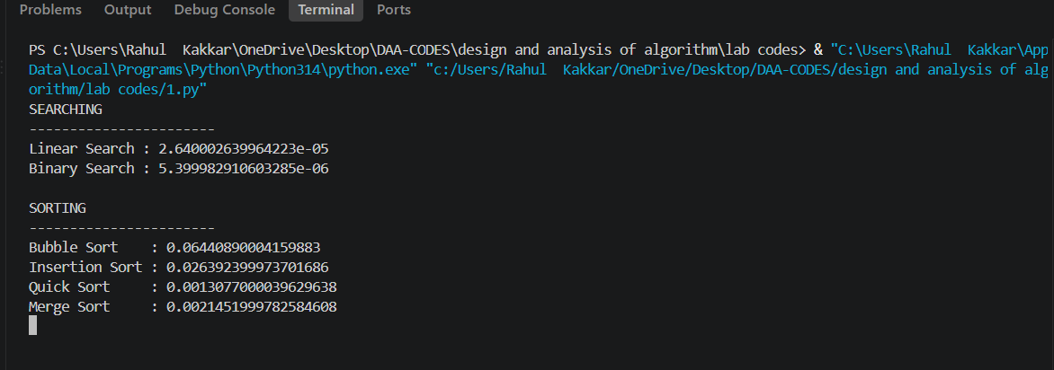

Graph of time comparison:
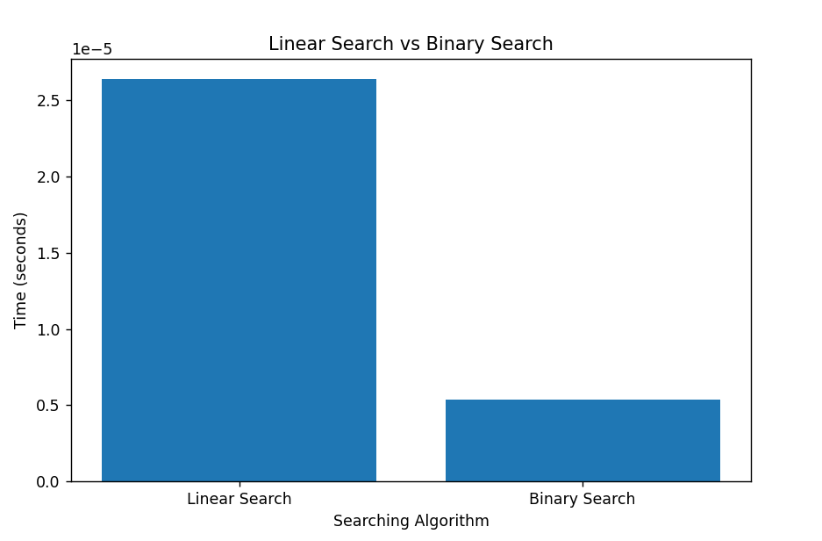
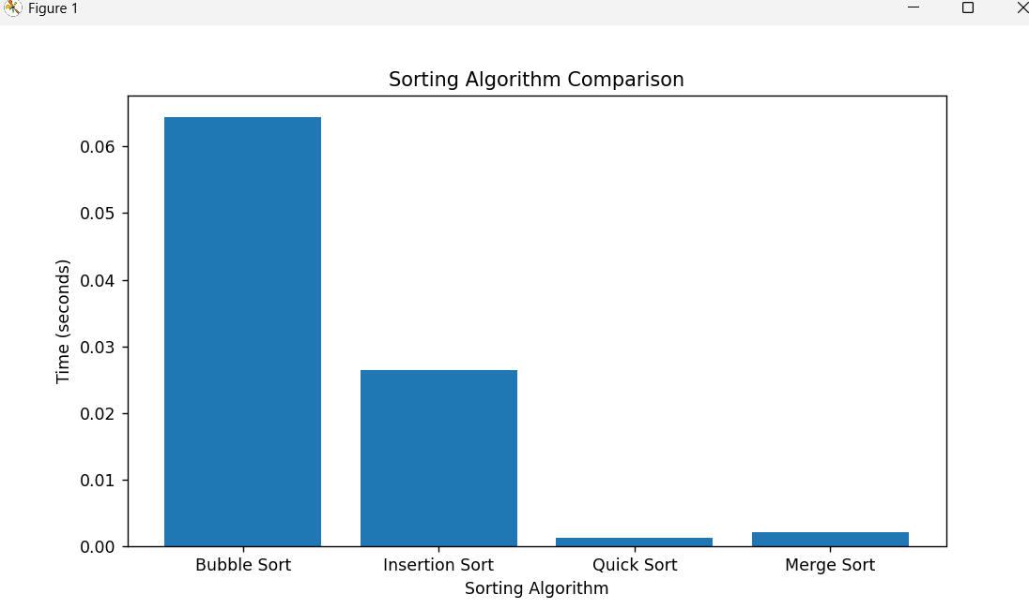

Understanding- This experiment helps us understand the difference in performance between various searching and sorting algorithms by measuring their execution time. For searching, Linear Search checks elements one by one, while Binary Search repeatedly divides a sorted array into two parts, making it much faster for large datasets. For sorting, Bubble Sort and Insertion Sort generally take more time as the number of elements increases, whereas Quick Sort and Merge Sort are usually faster for larger datasets. The Python program uses the time module to measure the execution time of each algorithm and matplotlib to represent the results graphically. The graphs make it easier to visualize how algorithm efficiency changes with the size of the input. Overall, this experiment shows why choosing an efficient algorithm is important when working with large amounts of data.

Q2.Kruskal algorithm

Code:
#include <stdio.h>
#include <stdlib.h>

#define MAX 100

// Structure to represent an edge
struct Edge
{
int src;
int dest;
int weight;
};

// ----------------------------------------------------
// Find function with Path Compression
// ----------------------------------------------------
int find(int parent[], int vertex)
{
if (parent[vertex] != vertex)
{
parent[vertex] = find(parent, parent[vertex]);
}

return parent[vertex];
}

// ----------------------------------------------------
// Union function using Union by Rank
// ----------------------------------------------------
void unionSets(int parent[], int rank[], int u, int v)
{
int rootU = find(parent, u);
int rootV = find(parent, v);

if (rootU != rootV)
{
if (rank[rootU] < rank[rootV])
{
parent[rootU] = rootV;
}
else if (rank[rootU] > rank[rootV])
{
parent[rootV] = rootU;
}
else
{
parent[rootV] = rootU;
rank[rootU]++;
}
}
}

// ----------------------------------------------------
// Comparison function for qsort()
// Sorts edges in ascending order of weight
// ----------------------------------------------------
int compareEdges(const void *a, const void *b)
{
const struct Edge *edge1 = (const struct Edge *)a;
const struct Edge *edge2 = (const struct Edge *)b;

if (edge1->weight < edge2->weight)
return -1;

if (edge1->weight > edge2->weight)
return 1;

return 0;
}

// ----------------------------------------------------
// Main Function
// ----------------------------------------------------
int main()
{
int V, E;
int i;

int edgeCount = 0;
int totalCost = 0;

struct Edge edges[MAX];

int parent[MAX];
int rank[MAX];

// Input number of vertices
printf("Enter number of vertices: ");
scanf("%d", &V);

// Input number of edges
printf("Enter number of edges: ");
scanf("%d", &E);

// Input all edges
printf("Enter source, destination and weight of each edge:\n");

for (i = 0; i < E; i++)
{
scanf("%d %d %d",
&edges[i].src,
&edges[i].dest,
&edges[i].weight);
}

// ------------------------------------------------
// STEP 1: Sort edges in increasing order of weight
// ------------------------------------------------
qsort(edges, E, sizeof(struct Edge), compareEdges);

// ------------------------------------------------
// STEP 2: Initialize Disjoint Set
// ------------------------------------------------
for (i = 0; i < V; i++)
{
parent[i] = i;
rank[i] = 0;
}

printf("\nEdges in Minimum Spanning Tree:\n");

// ------------------------------------------------
// STEP 3: Process edges from smallest to largest
// ------------------------------------------------
for (i = 0; i < E && edgeCount < V - 1; i++)
{
int u = edges[i].src;
int v = edges[i].dest;

int rootU = find(parent, u);
int rootV = find(parent, v);

// If roots are different, adding the edge
// will NOT create a cycle
if (rootU != rootV)
{
printf("%d - %d : %d\n",
u,
v,
edges[i].weight);

totalCost += edges[i].weight;

// Combine the two sets
unionSets(parent, rank, u, v);

edgeCount++;
}
}

// Check whether MST was successfully formed
if (edgeCount == V - 1)
{
printf("\nMinimum Cost = %d\n", totalCost);
}
else
{
printf("\nMinimum Spanning Tree cannot be formed.\n");
}

return 0;
}

Output:
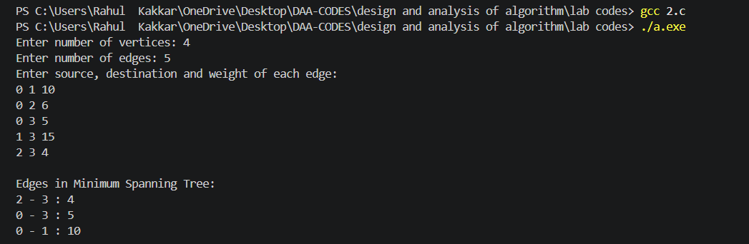
Understanding: Kruskal’s Algorithm is a greedy algorithm used to find the Minimum Spanning Tree (MST) of a weighted, undirected graph. It first sorts all edges in increasing order of weight and then selects the smallest edge that does not form a cycle. Union-Find with path compression and union by rank is used to detect cycles efficiently. The process continues until V−1 edges are selected, where V is the number of vertices. Its time complexity is O(E log E) because sorting the edges is the main operation.

Q3-linear vs binary search
Code:
Linear search:
#include <stdio.h>
#include <stdlib.h>
#include <time.h>

int linearSearch(int arr[], int n, int key, long *comparisons) {
for (int i = 0; i < n; i++) {
(*comparisons)++;

if (arr[i] == key) {
return i;
}
}

return -1;
}

int main() {

int n = 1000;
int arr[1000];

srand(42);

// Generate 1000 random numbers
for (int i = 0; i < n; i++) {
arr[i] = rand() % 10000;
}

printf("Generated %d random numbers.\n", n);

printf("First 10 elements: ");
for (int i = 0; i < 10; i++) {
printf("%d ", arr[i]);
}
printf("\n\n");

// Select 5 existing keys from different positions
int keysToFind[5];

for (int i = 0; i < 5; i++) {
keysToFind[i] = arr[(i * n) / 5];
}

// Key that is not present
int missingKey = -999;

double totalTime = 0.0;
long totalComparisons = 0;

// Search for the 5 existing keys
for (int i = 0; i < 5; i++) {

long comparisons = 0;

clock_t start = clock();

int index = linearSearch(
arr,
n,
keysToFind[i],
&comparisons
);

clock_t end = clock();

double timeTaken =
((double)(end - start)) /
CLOCKS_PER_SEC * 1000.0;

printf(
"Search %d: key = %d, found at index = %d, "
"comparisons = %ld, time = %.6f ms\n",
i + 1,
keysToFind[i],
index,
comparisons,
timeTaken
);

totalTime += timeTaken;
totalComparisons += comparisons;
}

// Search for missing key
long comparisons = 0;

clock_t start = clock();

int index = linearSearch(
arr,
n,
missingKey,
&comparisons
);

clock_t end = clock();

double timeTaken =
((double)(end - start)) /
CLOCKS_PER_SEC * 1000.0;

printf(
"Search 6 (missing key): key = %d, found at index = %d, "
"comparisons = %ld, time = %.6f ms\n",
missingKey,
index,
comparisons,
timeTaken
);

totalTime += timeTaken;
totalComparisons += comparisons;

// Calculate averages
printf(
"\nAverage comparisons per search: %.2f\n",
(double)totalComparisons / 6.0
);

printf(
"Average time per search: %.6f ms\n",
totalTime / 6.0
);

// Benchmark worst-case searching
int repeats = 100000;

long dummyComparisons = 0;

clock_t benchStart = clock();

for (int r = 0; r < repeats; r++) {
linearSearch(
arr,
n,
missingKey,
&dummyComparisons
);
}

clock_t benchEnd = clock();

double benchTime =
((double)(benchEnd - benchStart)) /
CLOCKS_PER_SEC * 1000.0;

printf(
"\nBenchmark: %d worst-case searches took %.3f ms total, "
"%.6f ms per search\n",
repeats,
benchTime,
benchTime / repeats
);

return 0;
}

Output:
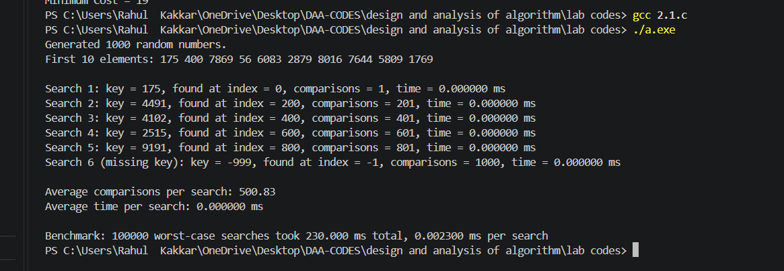

Binary search:
#include <stdio.h>
#include <stdlib.h>
#include <time.h>

// Comparison function used by qsort()
int compareInts(const void *a, const void *b) {
return *(int *)a - *(int *)b;
}

// Binary Search function
int binarySearch(int arr[], int n, int key, long *comparisons) {

int low = 0;
int high = n - 1;

while (low <= high) {

(*comparisons)++;

int mid = low + (high - low) / 2;

if (arr[mid] == key) {
return mid;
}
else if (arr[mid] < key) {
low = mid + 1;
}
else {
high = mid - 1;
}
}

return -1;
}

int main() {

int n = 1000;
int arr[1000];

srand(42);

// Generate random numbers
for (int i = 0; i < n; i++) {
arr[i] = rand() % 10000;
}

// Sort array because binary search requires sorted data
qsort(
arr,
n,
sizeof(int),
compareInts
);

printf("Generated and sorted %d random numbers.\n", n);

printf("First 10 elements after sorting: ");

for (int i = 0; i < 10; i++) {
printf("%d ", arr[i]);
}

printf("\n\n");

// Select 5 keys from different positions
int keysToFind[5];

for (int i = 0; i < 5; i++) {
keysToFind[i] = arr[(i * n) / 5];
}

// Missing key
int missingKey = -999;

double totalTime = 0.0;
long totalComparisons = 0;

// Search for 5 existing keys
for (int i = 0; i < 5; i++) {

long comparisons = 0;

clock_t start = clock();

int index = binarySearch(
arr,
n,
keysToFind[i],
&comparisons
);

clock_t end = clock();

double timeTaken =
((double)(end - start)) /
CLOCKS_PER_SEC * 1000.0;

printf(
"Search %d: key = %d, found at index = %d, "
"comparisons = %ld, time = %.6f ms\n",
i + 1,
keysToFind[i],
index,
comparisons,
timeTaken
);

totalTime += timeTaken;
totalComparisons += comparisons;
}

// Search for missing key
long comparisons = 0;

clock_t start = clock();

int index = binarySearch(
arr,
n,
missingKey,
&comparisons
);

clock_t end = clock();

double timeTaken =
((double)(end - start)) /
CLOCKS_PER_SEC * 1000.0;

printf(
"Search 6 (missing key): key = %d, found at index = %d, "
"comparisons = %ld, time = %.6f ms\n",
missingKey,
index,
comparisons,
timeTaken
);

totalTime += timeTaken;
totalComparisons += comparisons;

// Average comparisons and time
printf(
"\nAverage comparisons per search: %.2f\n",
(double)totalComparisons / 6.0
);

printf(
"Average time per search: %.6f ms\n",
totalTime / 6.0
);

// Benchmark worst-case searches
int repeats = 100000;

long dummyComparisons = 0;

clock_t benchStart = clock();

for (int r = 0; r < repeats; r++) {

binarySearch(
arr,
n,
missingKey,
&dummyComparisons
);
}

clock_t benchEnd = clock();

double benchTime =
((double)(benchEnd - benchStart)) /
CLOCKS_PER_SEC * 1000.0;

printf(
"\nBenchmark: %d worst-case searches took %.3f ms total, "
"%.6f ms per search\n",
repeats,
benchTime,
benchTime / repeats
);

return 0;
}
Output: 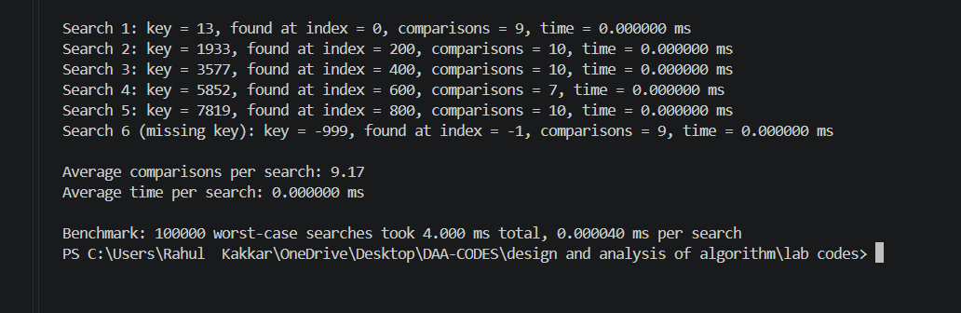

Graph comparison:
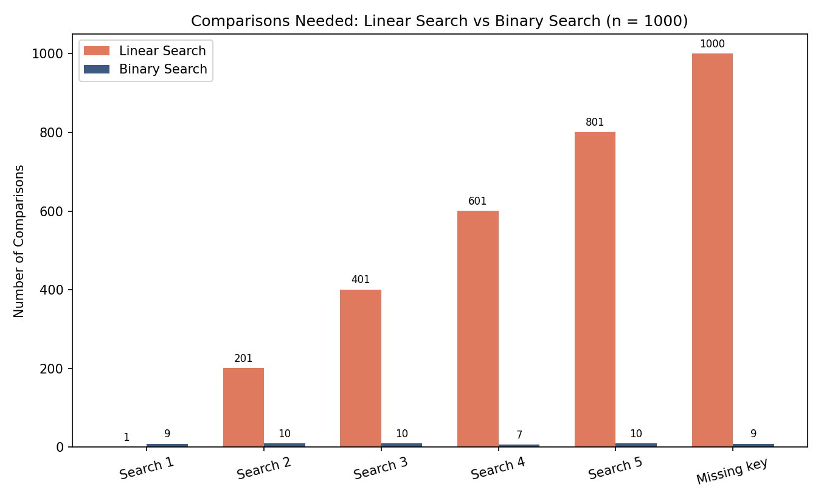
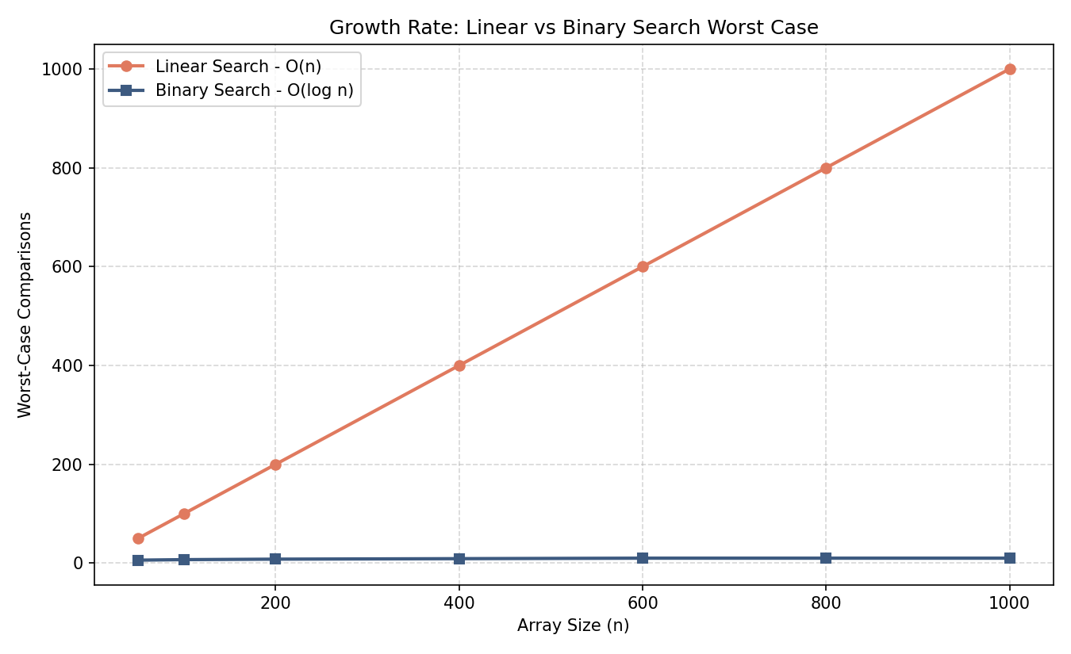

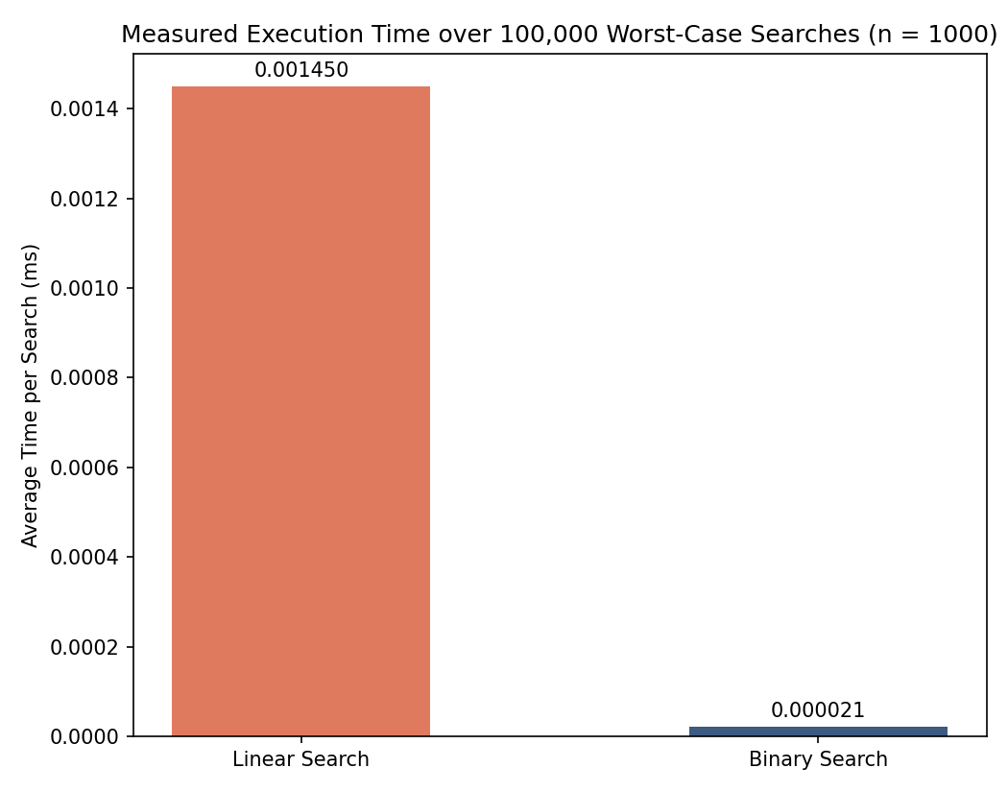
Understanding: Binary search is superior to linear search for large datasets because its $O\left(\log{n}\right)$ time complexity dramatically reduces lookups compared to linear search's $O\left(n\right)$ linear scan. However, binary search requires $O\left(n\log{n}\right)$ upfront time (and potentially additional space) to sort the data first, making linear search the more efficient, zero-overhead $O\left(1\right)$ choice for small lists or one-off searches.

Q4. Celebrity problem
Code:
#include <stdio.h>

#define N 4

// Function to find the celebrity
int findCelebrity(int M[N][N])
{
int candidate = 0;

// Step 1: Find a possible celebrity
for (int i = 1; i < N; i++)
{
// If candidate knows i,
// candidate cannot be a celebrity
if (M[candidate][i] == 1)
{
candidate = i;
}
}

// Step 2: Verify the candidate
for (int i = 0; i < N; i++)
{
if (i != candidate)
{
// Celebrity should know nobody
// AND everybody should know celebrity

if (M[candidate][i] == 1 ||
M[i][candidate] == 0)
{
return -1;
}
}
}

// Candidate satisfies both conditions
return candidate;
}

int main()
{
int M[N][N] =
{
{0, 1, 1, 0},
{0, 0, 1, 0},
{0, 0, 0, 0},
{0, 0, 1, 0}
};

int celebrity = findCelebrity(M);

if (celebrity == -1)
{
printf("There is no celebrity.\n");
}
else
{
printf("Person %d is the celebrity.\n", celebrity);
}

return 0;
}

Output:
